Project Title | RespectNet: Detect offensive language
Track | Information Technology & Computer Science/ CSCI417/ECEN425: Machine Intelligence
Supervisor | Dr.Ghada Khoriba | Mentor Name | Mina Atef Yousef
Team Name | Bit by Bit
Team Members | Merna Salem | Rawan Ayman | Shahd Ayman
Team Members | Farah Amr | Trevena Ayman | Moura Saber
Problem Summary | Offensive language is a prevalent issue in online communication, demanding predictive models for efficient identification. This study employs various machine learning models, including KNN, logistic regression, naive Bayes, SVM, and decision trees and random forest to detect offensive language. The dataset was curated through data scraping from the social media platform Twitter, encompassing diverse instances of harmful language.  The analysis involves implementing and evaluating these models using performance metrics such as precision, recall, and F1-score. Additionally, ensemble techniques, a method combining multiple models to improve predictive performance, are applied. Ensemble models leverage the strengths of individual models to produce a more accurate and robust prediction by aggregating their outputs.
Methodology | In our machine learning project to predict offensive language, we obtained our data-by-Data Scrapping from twitter. After collecting the data, we cleaned and prepared it by removing irrelevant information, handling missing values, and mapping the text. We then chose six machine learning models (KNN, logistic regression, naive Bayes, SVM, decision trees and random forest) and adjusted their settings using a technique called grid search to find the best set of hyperparameters for our models. Finally, the data was modeled, we chose algorithms of supervised learning, data was 70%-30% split and we vectorized the data. The models were implemented. A confusion matrix was created to summarize the performances of the models, classification report to provide us with detailed summary of important metrics such as precision, recall, F1-score, and support for each class in the classification problem, and finally, cross validated the models and observed their accuracies and then we did ensemble model to choose the most optimized model and to leverage the collective wisdom of multiple models to achieve better overall performance compared to individual models.
Achievements and Skills Gained | - Data Scrapping  - Data Preprocessing and Cleaning  - Models Development  - Hyperparameter Optimization and Cross validation  - Models Evaluation  - Ensemble Model

Project Title | RespectNet: Detect offensive language
Main Results | Random Forest (RF) has the highest accuracy (0.866).  K-Nearest Neighbors (KNN) has the second-highest accuracy (0.833).  Support Vector Machine (SVM) has accuracy of (0.8)  Logistic Regression (LR) follows with the third-highest accuracy (0.7666666666666667).  Naive Bayes and Decision Tree have the same accuracy (0.7).  Based solely on accuracy, the RF model performs the best on this dataset, followed closely by KNN and SVM, while Logistic Regression, Decision Tree, and Naive Bayes follow in descending order.  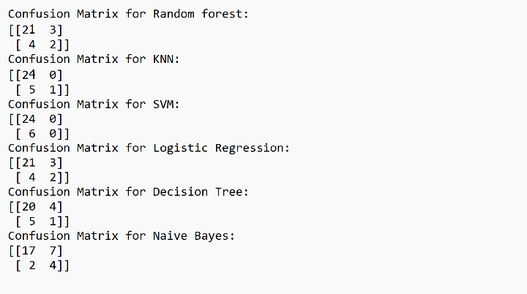
Discussion and Conclusion | In conclusion, this project has successfully developed a machine learning model for the detection of offensive language in text. The automated system demonstrates promising results, accurately identifying, and classifying harmful content. By integrating this model into content moderation systems and social media platforms, we can proactively address instances of offensive language, fostering a safer and more respectful online environment. The outcomes of this project contribute to the ongoing efforts of creating a digital space that promotes inclusivity, tolerance, and constructive dialogue.  Results indicated that SVM performed the best with the highest accuracy (0.8), followed closely by Logistic Regression (0.7666666666666667). KNN and Decision Tree had similar accuracies (0.7333333333333333), while Naive Bayes performed slightly lower (0.7). The study highlighted the efficacy of SVM and Logistic Regression in identifying offensive language, suggesting potential future research areas for model refinement and ensemble techniques to improve detection systems.
References | - Lectures And Labs
Future Work and Suggestions | Future research may focus on refining models for improved Offensive language detection systems.
Group Photo | 

